# db.products.insertMany([
{ "_id" : 1, "name" : "xPhone", "price" : 799, "releaseDate": ISODate("2011-05-14"), "spec" : { "ram" : 4, "screen" : 6.5, "cpu" : 2.66 },"color":["white","black"],"storage":[64,128,256]},
{ "_id" : 2, "name" : "xTablet", "price" : 899, "releaseDate": ISODate("2011-09-01") , "spec" : { "ram" : 16, "screen" : 9.5, "cpu" : 3.66 },"color":["white","black","purple"],"storage":[128,256,512]},
{ "_id" : 3, "name" : "SmartTablet", "price" : 899, "releaseDate": ISODate("2015-01-14"), "spec" : { "ram" : 12, "screen" : 9.7, "cpu" : 3.66 },"color":["blue"],"storage":[16,64,128]},
{ "_id" : 4, "name" : "SmartPad", "price" : 699, "releaseDate": ISODate("2020-05-14"),"spec" : { "ram" : 8, "screen" : 9.7, "cpu" : 1.66 },"color":["white","orange","gold","gray"],"storage":[128,256,1024]},
{ "_id" : 5, "name" : "SmartPhone", "price" : 599,"releaseDate": ISODate("2022-09-14"), "spec" : { "ram" : 4, "screen" : 9.7, "cpu" : 1.66 },"color":["white","orange","gold","gray"],"storage":[128,256]}
])

1. db.products.find({
price: {
$eq: 899
}
}, {
name: 1,
price: 1
})
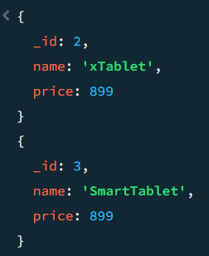
2. db.products.find({
"spec.ram": {
$eq: 4
}
}, {
name: 1,
"spec.ram": 1
})
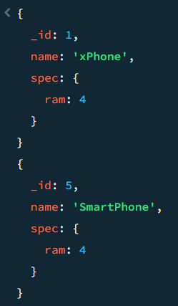
3. db.products.find({
color: {
$eq: "black"
}
}, {
name: 1,
color: 1
})
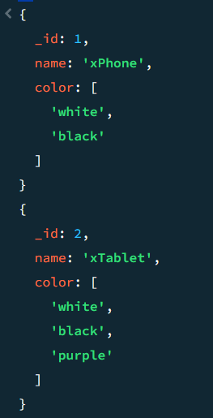
4. db.products.find({
releaseDate: {
$eq: new ISODate("2020-05-14")
}
}, {
name: 1,
releaseDate: 1
})
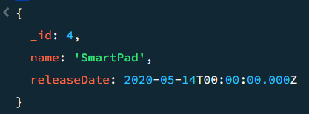

(for in and not in)
# db.products.insertMany([
{ "_id" : 1, "name" : "xPhone", "price" : 799, "releaseDate": ISODate("2011-05-14"), "spec" : { "ram" : 4, "screen" : 6.5, "cpu" : 2.66 },"color":["white","black"],"storage":[64,128,256]},
{ "_id" : 2, "name" : "xTablet", "price" : 899, "releaseDate": ISODate("2011-09-01") , "spec" : { "ram" : 16, "screen" : 9.5, "cpu" : 3.66 },"color":["white","black","purple"],"storage":[128,256,512]},
{ "_id" : 3, "name" : "SmartTablet", "price" : 899, "releaseDate": ISODate("2015-01-14"), "spec" : { "ram" : 12, "screen" : 9.7, "cpu" : 3.66 },"color":["blue"],"storage":[16,64,128]},
{ "_id" : 4, "name" : "SmartPad", "price" : 699, "releaseDate": ISODate("2020-05-14"),"spec" : { "ram" : 8, "screen" : 9.7, "cpu" : 1.66 },"color":["white","orange","gold","gray"],"storage":[128,256,1024]},
{ "_id" : 5, "name" : "SmartPhone", "price" : 599,"releaseDate": ISODate("2022-09-14"), "spec" : { "ram" : 4, "screen" : 5.7, "cpu" : 1.66 },"color":["white","orange","gold","gray"],"storage":[128,256]}
])

1. db.products.find({
price: {
$in: [699, 799]
}
}, {
name: 1,
price: 1
})
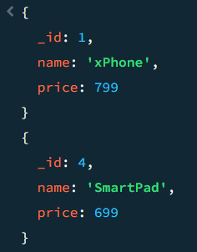

2. db.products.find({
color: {
$in: ["black", "white"]
}
}, {
name: 1,
color: 1
})
(OR)
db.products.find({
color: {
$in: [/^g+/, /^w+/]
}
}, {
name: 1,
color: 1
})

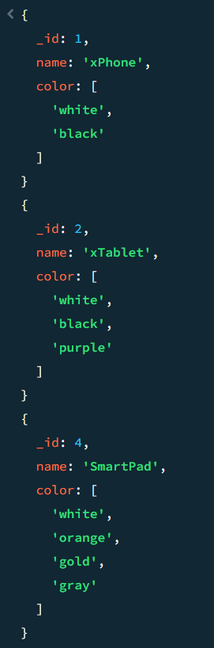
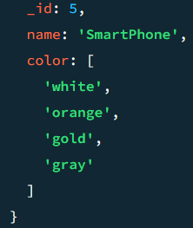
3. db.products.find({
price: {
$nin: [699, 799]
}
}, {
name: 1,
price: 1
})
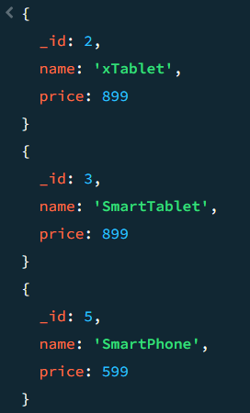

# db.products.insertMany([
{ "_id" : 1, "name" : "xPhone", "price" : 799, "releaseDate" : ISODate("2011-05-14T00:00:00Z"), "spec" : { "ram" : 4, "screen" : 6.5, "cpu" : 2.66 }, "color" : [ "white", "black" ], "storage" : [ 64, 128, 256 ] },
{ "_id" : 2, "name" : "xTablet", "price" : 899, "releaseDate" : ISODate("2011-09-01T00:00:00Z"), "spec" : { "ram" : 16, "screen" : 9.5, "cpu" : 3.66 }, "color" : [ "white", "black", "purple" ], "storage" : [ 128, 256, 512 ] },
{ "_id" : 3, "name" : "SmartTablet", "price" : 899, "releaseDate" : ISODate("2015-01-14T00:00:00Z"), "spec" : { "ram" : 12, "screen" : 9.7, "cpu" : 3.66 }, "color" : [ "blue" ], "storage" : [ 16, 64, 128 ] },
{ "_id" : 4, "name" : "SmartPad", "price" : 699, "releaseDate" : ISODate("2020-05-14T00:00:00Z"), "spec" : { "ram" : 8, "screen" : 9.7, "cpu" : 1.66 }, "color" : [ "white", "orange", "gold", "gray" ], "storage" : [ 128, 256, 1024 ] },
{ "_id" : 5, "name" : "SmartPhone", "price" : 599, "releaseDate" : ISODate("2022-09-14T00:00:00Z"), "spec" : { "ram" : 4, "screen" : 9.7, "cpu" : 1.66 }, "color" : [ "white", "orange", "gold", "gray" ], "storage" : [ 128, 256 ] },
{ "_id" : 6, "name" : "xWidget", "spec" : { "ram" : 64, "screen" : 9.7, "cpu" : 3.66 }, "color" : [ "black" ], "storage" : [ 1024 ] }
])

1. db.products.find({
$and: [{
price: 899
}, {
color: {
$in: ["white", "black"]
}
}]
}, {
name: 1,
price: 1,
color: 1
})
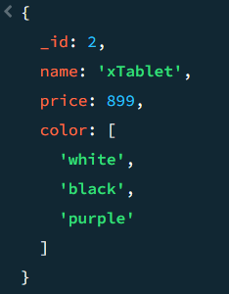
2. db.products.find({
$or: [
{price: {$lt: 699} },
{price: {$gt: 799} }
]
}, {
name: 1,
price: 1
})
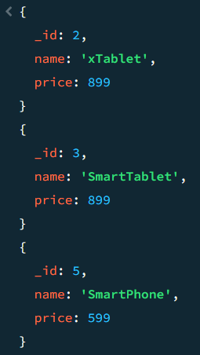
3. db.products.find({
price: {
$not: {
$gt: 699
}
}
}, {
name: 1,
price: 1
})
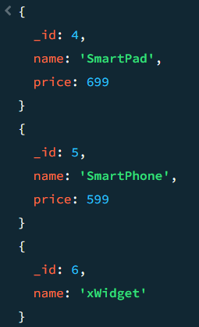
4. db.products.find({
name: {
$not: /^Smart+/
}
}, {
name: 1
})
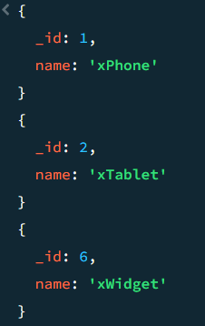
5. db.products.find({
price: {
$lte: 699
}
}, {
name: 1,
price: 1
})
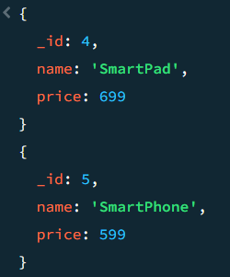
6. db.products.find({
$nor: [
{price: 899},
{color: "gold"}
]
}, {
name: 1,
price: 1,
color: 1
})
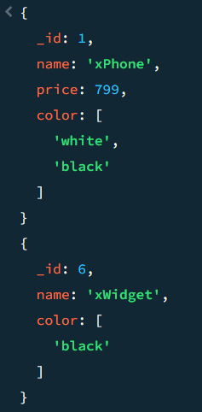

# db.products.insertMany([
{ "_id" : 1, "name" : "xPhone", "price" : 799, "releaseDate" : ISODate("2011-05-14T00:00:00Z"), "spec" : { "ram" : 4, "screen" : 6.5, "cpu" : 2.66 }, "color" : [ "white", "black" ], "storage" : [ 64, 128, 256 ] },
{ "_id" : 2, "name" : "xTablet", "price" : 899, "releaseDate" : ISODate("2011-09-01T00:00:00Z"), "spec" : { "ram" : 16, "screen" : 9.5, "cpu" : 3.66 }, "color" : [ "white", "black", "purple" ], "storage" : [ 128, 256, 512 ] },
{ "_id" : 3, "name" : "SmartTablet", "price" : 899, "releaseDate" : ISODate("2015-01-14T00:00:00Z"), "spec" : { "ram" : 12, "screen" : 9.7, "cpu" : 3.66 }, "color" : [ "blue" ], "storage" : [ 16, 64, 128 ] },
{ "_id" : 4, "name" : "SmartPad", "price" : 699, "releaseDate" : ISODate("2020-05-14T00:00:00Z"), "spec" : { "ram" : 8, "screen" : 9.7, "cpu" : 1.66 }, "color" : [ "white", "orange", "gold", "gray" ], "storage" : [ 128, 256, 1024 ] },
{ "_id" : 5, "name" : "SmartPhone", "price" : 599, "releaseDate" : ISODate("2022-09-14T00:00:00Z"), "spec" : { "ram" : 4, "screen" : 9.7, "cpu" : 1.66 }, "color" : [ "white", "orange", "gold", "gray" ], "storage" : [ 128, 256 ] },
{ "_id" : 6, "name" : "xWidget", "spec" : { "ram" : 64, "screen" : 9.7, "cpu" : 3.66 }, "color" : [ "black" ], "storage" : [ 1024 ] },
{ "_id" : 7, "name" : "xReader","price": null, "spec" : { "ram" : 64, "screen" : 6.7, "cpu" : 3.66 }, "color" : [ "black", "white" ], "storage" : [ 128 ] }
])

1. db.products.find({
price: {
$exists: true
}
}, {
name: 1,
price: 1
})
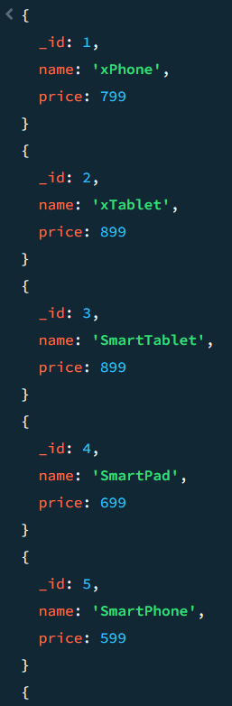
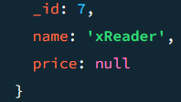
2. db.products.find({
price: {
$exists: true,
$gt: 699
}
}, {
name: 1,
price: 1
})
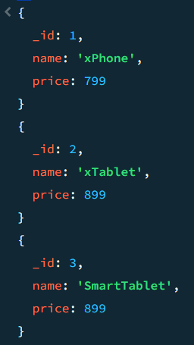
3. db.products.find({
price: {
$exists: false
}
}, {
name: 1,
price: 1
}
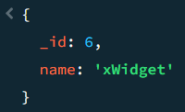

(for type)
# db.products.insertMany([
{ "_id" : 1, "name" : "xPhone", "price" : "799", "releaseDate" : ISODate("2011-05-14T00:00:00Z"), "spec" : { "ram" : 4, "screen" : 6.5, "cpu" : 2.66 }, "color" : [ "white", "black" ], "storage" : [ 64, 128, 256 ] },
{ "_id" : 2, "name" : "xTablet", "price" : NumberInt(899), "releaseDate" : ISODate("2011-09-01T00:00:00Z"), "spec" : { "ram" : 16, "screen" : 9.5, "cpu" : 3.66 }, "color" : [ "white", "black", "purple" ], "storage" : [ 128, 256, 512 ] },
{ "_id" : 3, "name" : "SmartTablet", "price" : NumberLong(899), "releaseDate" : ISODate("2015-01-14T00:00:00Z"), "spec" : { "ram" : 12, "screen" : 9.7, "cpu" : 3.66 }, "color" : [ "blue" ], "storage" : [ 16, 64, 128 ] },
{ "_id" : 4, "name" : "SmartPad", "price" : [599, 699, 799], "releaseDate" : ISODate("2020-05-14T00:00:00Z"), "spec" : { "ram" : 8, "screen" : 9.7, "cpu" : 1.66 }, "color" : [ "white", "orange", "gold", "gray" ], "storage" : [ 128, 256, 1024 ] },
{ "_id" : 5, "name" : "SmartPhone", "price" : ["599",699], "releaseDate" : ISODate("2022-09-14T00:00:00Z"), "spec" : { "ram" : 4, "screen" : 9.7, "cpu" : 1.66 }, "color" : [ "white", "orange", "gold", "gray" ], "storage" : [ 128, 256 ] },
{ "_id" : 6, "name" : "xWidget", "spec" : { "ram" : 64, "screen" : 9.7, "cpu" : 3.66 }, "color" : [ "black" ], "storage" : [ 1024 ] }
])

1. db.products.find({
price: {
$type: "string"
}
}, {
name: 1,
price: 1
})
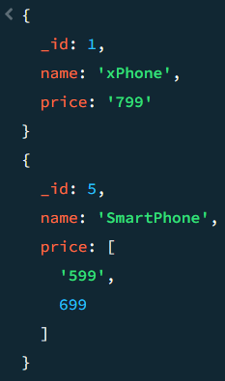
2. db.products.find({
price: {
$type: 2
}
}, {
name: 1,
price: 1
})
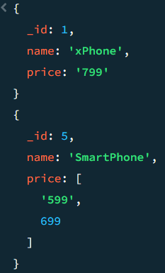
3. db.products.find({
price: {
$type: "number"
}
}, {
name: 1,
price: 1
})
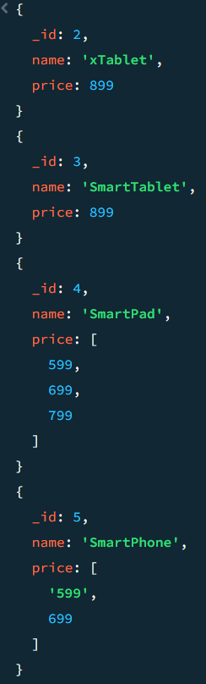
4. db.products.find({
price: {
$type: ["number", "string"]
}
}, {
name: 1,
price: 1
})
